IGNIS V1 End-to-End Automated System Execution

python -m unittest discover tests

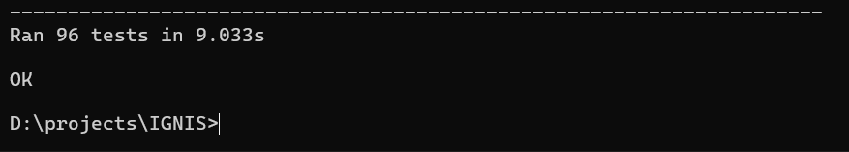

docker compose up --build -d
